BarcelonaTech Team Results Document

Team name:
BarcelonaTech

Team members:

Pouya Mehrdel
Shadi Karimi

Responsible professors:

Jasmina Casals-Terré

Universitat Politècnica de Cataluna-Universitat de Vic
2018-08-23

Contents
Summary for the SensUs website ......................................................................................................... 3

1. Biosensor System and Assay......................................................................................................... 4

2. Analytical Performance ................................................................................................................. 7

3. Novelty and Creativity ................................................................................................................... 8

3.1. Already available ................................................................................................................... 8

3.2. New developments ................................................................................................................ 8

4. Translation Potential ..................................................................................................................... 9

4.1. Healthcare application potential .......................................................................................... 9

4.2. Industrialization and commercialization potential ............................................................ 9

5. Team and Support ....................................................................................................................... 11

5.1. Contributions of the team members .................................................................................. 11

5.2. People who have given support.......................................................................................... 11

5.3. Sponsors ............................................................................................................................... 12

6. Final remarks ............................................................................................................................... 13

Summary for the SensUs website

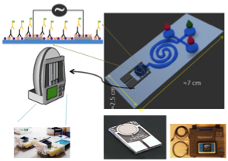

Figure 1. Sensor schematics

This project aims at measuring the concentration of Vancomycin in biological samples, provided by the Sensus competition organizer. Several methods are known and already have been widely used for measuring the components of biological samples. From those, ELISA method is one the best known and can detect components with a significant accuracy. ELISA can be performed with different techniques. Generally, the final goal is to detect the color changes in the sample by evaluating the treated sample’s wavelength.
For every protein there is a specific antibody, produced by the immune system that can interact only with that protein via an ester in their chemical structure. In this project an indirect competitive ELISA will be performed on a surface of an inter-digitated electrode to detect the impedance characteristics of the sample. The results have demonstrated that the implementation of biomodified IDE electrodes to measure impedance after 1s and 2nd antibody coating optimize time to results for the simplified ELISA reading after 1st antibody obtaining results in less than 5 minutes. The proposed biosensor can also provide a high performance with the longer path (reading after 2nd antibody).
The strategy reported is extremely simple and potentially implemented in a point-of-care format with minimal technical requirements.

1. Biosensor System and Assay

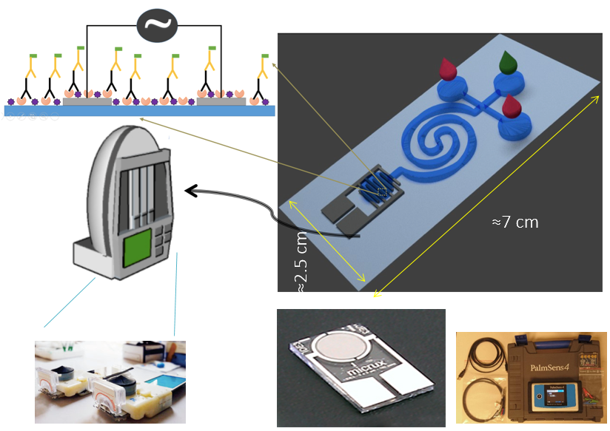

Figure 2 Full concept summarized in one picture.

One of the major aspects of the biosensor, the assay, is based on specific binding of antibodies and Vancomycin. To provide high specificity in the detection when the protein of interest is smaller than 10000 Daltons (1 Dalton is equal to the weight of 1 neutron/proton), it is highly recommended to use a competitive. In this case, where the Vancomycin is the subject of interest its weight is in the order of 1500 Daltons and this makes the competitive ELISA method eligible. The steps of the indirect competitive ELISA are almost similar to the procedure of the indirect ELISA.

Two antibodies have been used: anti-Vancomycin antibocy ( ab19968 Rabbit polyclonal to Vancomycin from Abcam ) at a dilution 1:1000 as recomended by the manufacturer and secondary antibody Goat Anti-Rabbit IgG (HRP) (ab205718 from Abcam) at a dilution 1:1000 as recomended by the manufacturer.

The secondary antibody ab205718 is conjugated with horse Radish Peroxidase (HRP), which gives a color at 450 nm and can help in validation with ELISA readers.

Micrux gold interdigitated electrodes with 180 pairs of electrodes separated 5 microns each are coated with Vancomycin at 0.25 ug/ml overnight at 4ºC. To achieve this coating the electrodes had been previously treated with PIRANHA cleaning and sank with (3-Aminopropyl)triethoxysilane (APTES) afterwards.

The surface of the electrode was then blocked with 2.5% milk in PBS solution for 30 minutes, see Figure 3 a.

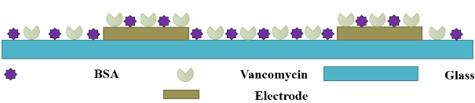
Blocking

(a)
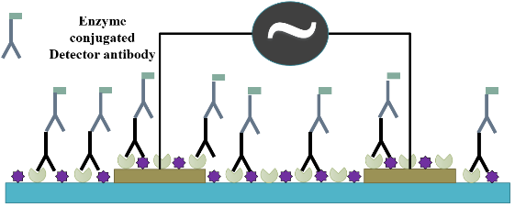

(b)
Figure 3 (a) Coating of the IDE electrode (b) Measurement step after 2nd Ab attachment

Secondly, there is a need for a microfluidic system in order to integrate the competitive elise and measuring part: It provides the infrastructure to mix and incubate antibodies with the biomarker and it furthermore to perform the readout of the sensor device.

Softlithography is used to create a mold for further manufacturing the micromixer cartridge using polydimentilsiloxane (PDMS).

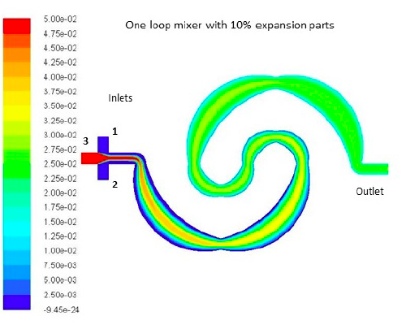
FIgure 4. Scalar concentration of the mixing step.

The sample and the Anti-Vancomycin antibody are injected into the mixer. Mixing is achieved by enhanced diffusion, through the designed mixing system, see Figure 4.
This step causes the 1st-antibodies (anti-VANCO) to connect to the existing Vancomycin molecules in the mixture and leaves fewer amounts of unattached capture antibodies in the solution. After introducing the mixture to the sensor, the remaining capture antibodies attach to the Vancomycin molecules, which were settled on the surface of the sensor beforehand. After incubating at 37˚C for 5 minutes and washing the sensor with PBS+Tween 0.05% solution for 3 times, the excessive entities are removed from the substrate.
Then, PalmSens4, a battery powered Frequency Response Analyzer (FRA) is used for impedance measurements at different frequencies.

If low concentration measurements are required, a second coating with the secondary antibody can be done incubating at 37º C for 5 more minutes and washing 3 more times with PBS+Tween 0.05% solution for 3 times.

2. Analytical Performance

The used secondary antibody is linked to HRP enzime, which provides as a colorimetry to validate the results by visual inspection of the electrode surface.
Afterwards, ic-ELISA assays were performed with impedance measurement unit (PALMSENSE 4) at different concentrations of known Vancomycin samples to calibrate the sensor. Results are shown in Figure 5 for all the frequencies analyzed (0 and 1 MHz).

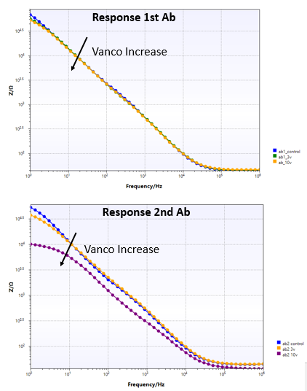

Figure 5 Impedance measurement at different frequencies after 1st and 2nd Ab readouts by Palmsense 4.

The minimum detected sample was 0.1 ug/ml but some further optimization of the coating time would have allowed the device to detect even smaller concentrations.
The maximum differences between concentrations appeared at low frequency, therefore the calibration plot, shown in Figure 6 is performed at 1 Hz frequency measurement.
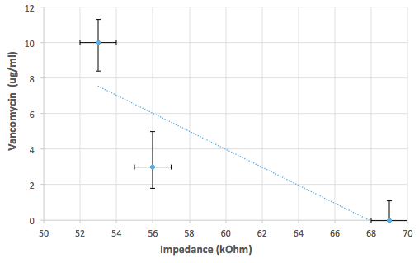

Figure 6 Calibration plot at 1Hz.

3. Novelty and Creativity

3.1. Already available

In general commercial off-the-shelf components have been used with the vision of achieving the commercialization of the sensor faster.
From the biological point of view the pair of antibodies used to capture and detect the analyte are used in common ELISA protocols. The APTES interaction to couple Vancomycin to glass is a well-known strategy.

The material used for the sensor and for the microfluidic cartridge are glass and glod electrode, manufactured by standard cleanroom protocols and provided by Micrux. The microfluidic cartridge is manufactured using softlithography using but it can also be achieve using a more industrial protocol such as femto laser maching due to its dimensions.

3.2. New developments

Current immunoassays require long protocols, since they need time for immobilization and several washing steps. To shorten the incubation time and maximize the sensor readout, BarcelonaTech decided to take the approach to use impedance spectroscopy combined with competitive indirect ELISA. Hence the used inter-digitated electrode with only 5 um distance are extremely sensitive to small amounts of deposited molecules changes.

Indirect competitive ELISA requires an initial mixture of the sample with primary antibody, the use of a novel microfluidic mixer which minimizes the use of real-state and maximizes the mixing optimizes this step.

Certain aspects of the sensor device introduce ground-breaking new approaches in comparison with available devices. Unlike traditional devices the readout circuitry is not based on a spectrometry, but on a portable impedance analyzer, which makes the device cheaper by a order of magnitude and also smaller. Therefore the device can be produced at a reasonable price as a Point of care product and its easy of use it makes it available to its use in practitioners office.

4. Translation Potential

4.1. Stakeholders desirability

Patients with severe infections that require last resource antibiotic vancomycin or with a cataract complication that needs surgery.
Power in the decision to buy the product

Doctors could use this device to know the vancomycin concentration in blood and be able to administer personalized doses with guarantees of its effectiveness.

Hospital managers would buy the device because, with a long-term future vision, investing in this equipment will bring benefits and effectiveness in the health public system.

Insurance companies could use this device to improve the quality of life of the patient. They want to be better than the public health system but administer adequate doses.

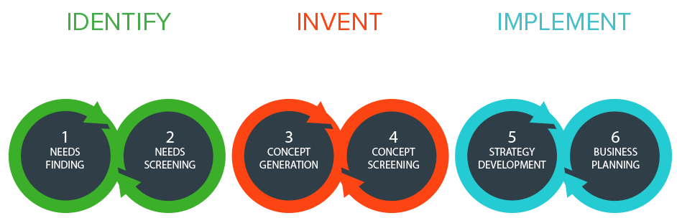

1. Not a real time process, since what is actually measure is the amount of vancomycin left in the organism after a certain period of time. If the hospital is situated in a big city, the sample is analysed there within 40 min- 5 hours. If not, it must be sent to a big hospital. This process can take one day.

2. Help isolated hospitals to perform by themselves this process with no need to derivate the sample to other hospitals. The results of the analysis will be real time.

3. Easy, fast, cheap, portable and accurate device capable of measuring vancomycin levels in blood. Comparable to devices already in the market same in speed and accuracy.

4. The perfect client will be hospitals that are isolated from big cities. Blood samples will not be shipped to other laboratories and hospitals saving time and giving results faster.

5 & 6. The biosensor would be sold as a pack including two parts, the biosensor and the chemical treated electrodes to do the test. Our business model will be based on razor’s blade model.

4.2. Technical Feasibility

One of the main goals of this system is to provide the user an effective and competent device able to obtain the results easier. Reducing the blood's sample extracted to the patient and getting a turnaround briefer, benefits serious patients when the tests need continuous blood extractions. Ensure the health of patient, provides an advantage to adapt specific therapies and to be able to carry out more tests that provide a more exhaustive follow-up. Also, the design and miniaturization of the device's components, the cartridge included, ensures the reduction of the handling by the user and contamination of blood samples.
Impedance biosensors are a class of electrical biosensors that show promise for point-of-care and other applications due to low cost, ease of miniaturization, and label-free operation. Nowadays some of these devices are competing for their market launch and, the vancomycin’s device designed follows this research lines.
The design and components that compound our biosensor are compatible with an industry process; the election of components completely commercials allow a mass production with a low cost. For the prototype's design, the industrialization played a decisive role; some relevant features were considered like the electrodes price or their reutilization. That allow evaluate some traits were extracted for avoid have a big gap between the prototype and the end product.

4.3 Business viability

A cost estimation of our biosensor system could be split in two parts; the cartridges with a cost of 25 euros, and the analyser instrument of about 200 euros. As stated before, our biosensor would be sold as a pack, including the biosensor and the chemically treated electrodes. Our business model would be based on razor’s blade model.
The reason why this model was chosen is that it the most common business model in the Spanish National Health System and hospitals such as Mutua of Terrasa and Bellvitge commonly buy products using this business model. Based on this, this business approach would be an easy and readily acceptable method in the purchasing process for hospitals.
The refills of the razor’s blade model would be our treated electrodes, whereas the product itself would be the biosensor. The first purchase of the pack would include the biosensor and 10 treated electrodes. Every time a test would be performed, a treated electrode would be used.
In 2016, the Ministry of Health, Social Services and Equality published in the Annual Report of the National Health System that there were 791 hospitals in Spain [1]. 72% of these hospitals had less than 200 bed-capacity, being considered as small [1]. These hospitals usually depend on bigger hospitals to perform tests due to lack of equipment available and therefore would be our ideal target, as our device would give independency from those hospitals and would make them save time and financial resources.

The total health expenditure in 2014 in Spain was 95.772 millions of euros, from which hospitals expenditures reached 39.930 millions [1]. Taking into account the expenditure in the health system and the number of small hospitals in Spain, we expect our business model to maintain the sales and finance capital.

5. Team and Support

5.1 Contributions of the team members
Andrea Fernández: contact person with the organizers of the competition. Also worked on marketing, the assignments and publicity.
Carlota Mestre: laboratory work; working on the laboratory trials looking for the best option to develop our biosensor.
Laura Mansilla: research information about chemical and technical processes and development on all laboratory trials.
Ramon Angosto: development of the microfluidic design.
Mar Galofré: work assignments, the marketing and the creation of social networks.
Shadi Karimi: development of the technological part of the biosensor.
Pouya Mehdrel: development of the technological part of the biosensor.
Jasmina Casals: responsible of the project. Work and supervision in all fields.

5.2. People who have given support
Montse Masoliver: laboratory head; research and development in chemical aspects and responsible for laboratory materials.
Laboratory staff: They have helped us with the processes and materials of the laboratory.

5.3. Sponsors
The University of Vic (UVic-UCC) and the Polytechnic University of Catalonia have provided us with all the materials, both biological and technological.

6. Final remarks

Working in this project has been an opportunity and a challenge. For the first time, we have faced a real objective, with the freedom to tackle it on our own. We have had to practice not only the so-called transversal skills (organization, report writing, time management, team work...) moreover we have also had to use our knowledge or gather it. At this point we are glad to see how technology can be used to try to mitigate the effects of antibiotic resistance and also help patients who are being treated with antibiotics for a long time.

7. References

[1] Ministry of Health, Social Services and Equality (2017). Annual Report of the National Health System. Available at https://www.mscbs.gob.es/estadEstudios/estadisticas/sisInfSanSNS/tablasEstadisticas/InfAnualSNS2016/Annual_Report_2016.1.pdf

