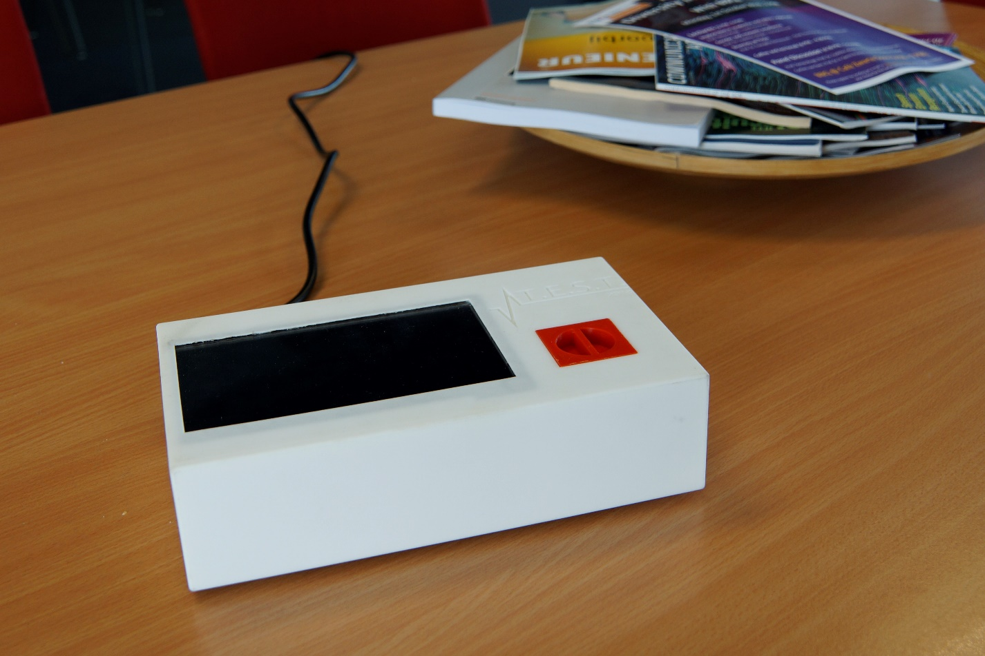
OUR BIOSENSOR IS YOUR LABORATORY AT HOME

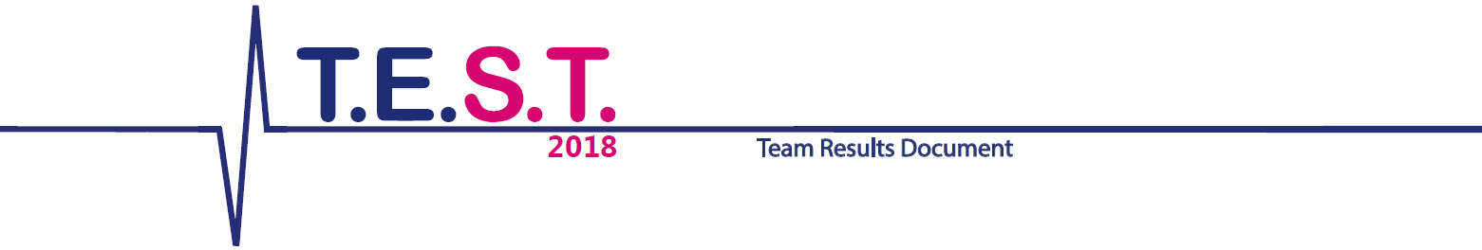

Team members: Saray Bakker, Lotte van Dasler, Robert van Dijk, Leander van Eekelen, Tom Franken, Janneke Lukkezen, Jorg Mallens, Céline Pereboom, Dennis v.d. Sande, Ralf Schmidt, Ivar de Vries
Date: August 28 2018

Summary
We are T.E.S.T. (TU/e Sensing Team) and we represent the Netherlands at the SensUs event. Our biosensor is smaller than a shoe box and as heavy as a two packs of sugar. Our measurement principle makes use of magnetic particles coated with vancomycin, and anti-vancomycin antibodies to specifically form dimers. In the presence of free vancomycin in the patient’s blood plasma the vancomycin coated particles and the free vancomycin are in competition to bind to the antibodies. Higher vancomycin concentration will thus lead to less particle-dimers in the solution. The number of particle-dimers is measured using an optomagnetic readout. In the future, to reduce healthcare costs instead of antibodies a D-Ala-D-Ala linker or beads coated with D-Ala-D-Ala can be used. D-Ala-D-Ala is part of the bacterial wall and vancomycin specifically binds to when it is used to kill bacteria.
Our biosensor will make it possible for patients to recover from for example a surgery with vancomycin in the comfort of their home instead of the hospital. Patients will no longer be required to give large amounts of blood, a small finger prick suffices. Vancomycin levels can still be monitored at home, while hospital workload is decreased by reducing the amount of occupied hospital beds

Table of Contents
Summary 2
Biosensor system and assay 4
Detection principle 4
Functionalization 4
Biosensor system 5
Analytical performance 6
Novelty and Creativity 7
Already available 7
New developments 7
Chemical developments 7
Hardware developments 7
Translation potential 8
Stakeholder desirability 8
Technological feasibility 8
Business viability 9
Investment proposition 10
Team and support 11
Contributions of the team members 11
People who have given support 11
Sponsors 11
Final remarks 12
References 13
General 13
Translation potential 13
Appendix 14
Revenue streams calculations 14

Biosensor system and assay

Detection principle
Vancomycin is detected using a particle cluster competition assay. Magnetic particles coated with vancomycin form in the presence of antibodies two-particle clusters, dimers. When a sample containing analyte vancomycin is added, the antibodies bind to the free vancomycin which blocks dimer formation. A high vancomycin concentration in a sample results a decrease in the number of particle dimers.
The biosensor system is designed to detect the number dimers of magnetic particles. A laser is used in combination with a photodiode to measure light scattering of the sample at a 90 degree angle with regard to the incoming laser light. This angle is chosen because it turned out to be the optimal angle for measuring scattered light from dimers.
The process of dimer formation, as described above, is a stochastic effect, purely based on the diffusion of the components in the solution. This would result in long measurement times, since the diffusion of micrometer sized particles is typically a slow process. However, using superparamagnetic particles, that behave magnetic only in the presence of an external magnetic field, the diffusion process can be accelerated. For this purpose, a pulsating magnetic field is used to alternatingly bring particles in close proximity to probe dimer formation and let them diffuse away from each other. An overview of the measuring and actuating cycle can be seen in figure 1.
When the sample is illuminated with the laser while a rotating magnetic field is present, the scattered light oscillates, due to the time-varying cross-section of dimers. Single beads have a constant cross-section, and will therefore not contribute to the time-dependency of the signal. A fast fourier transform (FFT) will be used in order to obtain the amplitude of the signal at the dimer rotation frequency. This signal is called the <|A2f|> peak. From this, the corresponding vancomycin concentration can be found. This detection principle was introduced by Andrea Ranzoni [1].
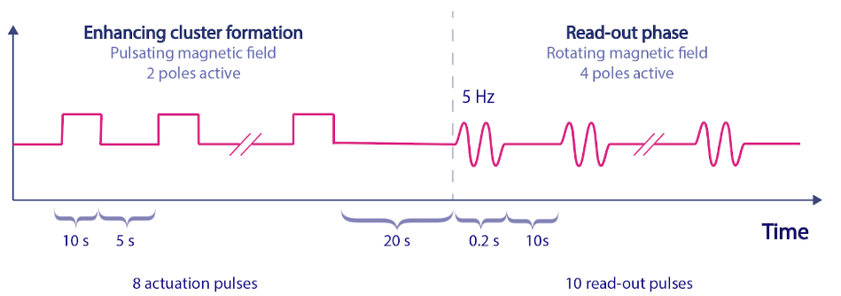
Our detection principle uses both actuation and measurement pulses with a magnetic field strength of 3.5 mT. We enhance dimer formation with 8 actuations pulses (figure 1) of 10 seconds. After each actuation pulse the field is turned off for 5 seconds. After the last actuation pulse the field is turned off for 20 seconds. The Read-out phase consists of 10 measurement pulses of 5 Hz lasting 0.2 seconds each. Between each measurement pulse a waiting period of 10 seconds is implemented. Each measurement pulse is processed by the FFT. The 10 results are averaged to determine the concentration of vancomycin.
Figure 1: Overview of the magnetic field cycle during a complete measurement

Functionalization
The particles used are functionalized magnetic particles. The magnetic nanoparticles have a carboxylic acid surface and a diameter of 500 nm. These particles are then functionalized with vancomycin using an EDC/NHS coupling reaction dissolved in a MES buffer.
For the coupling reaction, the surface carboxyl groups are activated by means of a solution of EDC (1-Ethyl-3-(3-dimethylaminopropyl)carbodiimide) in cold MES buffer (2-(N-morpholino)ethanesulfonic acid). Because the activated carboxyl groups have a short half-life, the EDC groups are therefore substituted with NHS groups (N-Hydroxysuccinimide). This increases the half-life of the activated carboxyl groups. The NHS groups are then subsequently replaced with vancomycin. The particles are in the EDC/NHS solution for 30 minutes. The EDC/NHS solution is removed and vancomycin dissolved in PBS is added. This will react for 1 hour and the solution is again removed. To block any remaining NHS ethanolamine is added in a large excess for one hour. After removal of the solution the particles are washed 4 times in a buffer of PBS, BSA and Tween 20 and also stored in this buffer.

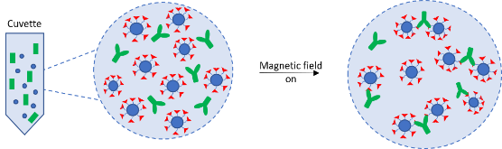
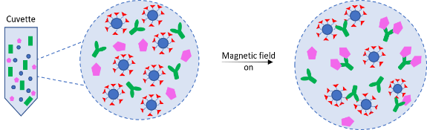
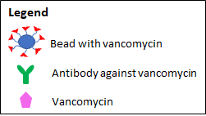
In the solution poly-immunoglobulin G antibodies are present, purchased from Thermo Fisher (# PA1-85957). These antibodies enable the functionalized particles to form dimers. The dimers are necessary for the determination of the concentration of vancomycin in blood plasma, as described in the detection principle.
Figure 2: (a) a cuvette without any free vancomycin. (b) a cuvette with free vancomycin

Biosensor system
The Raspberry Pi 3B is in essence the brain of the sensor. This computer controls the quadrupole magnet, the touchscreen and the photodiode. To achieve this, two Digital-Analog Converters (DAC) and one Analog-Digital Converter (ADC) are used. The DACs convert the digital signals sent from the Raspberry Pi into analog signals within the range of 0 to 5 volts. With analog signals, the quadrupole magnet can be controlled. The ADC converts the analog signal received from the photodiode into a digital signal (a bitstring) which the Raspberry Pi can process as shown in figure 3.
The measuring principle of the biosensor system makes use of a laser (660nm, 70mW). To make sure that the laser hits the cuvette with the light beam perpendicular to the side of the cuvette, a Plano-convex lens with f = 40.0 mm is used. This lens focuses the light of the laser in the center of the cuvette, after which the light scatters under an angle of 90 degrees. After the laser leaves the sample, it goes through a Bi-convex lens with f = 15.0 mm. This lens, in turn, focuses the light on the photodiode.
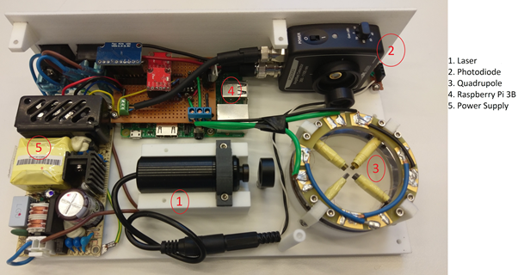
Figure 3: Inside of the biosensor and its components.
1. Laser
2. Photodiode
3. Quadrupole magnet
4. Raspberry Pi 3B
5. Power supply

Analytical performance
To evaluate the analytical performance of our biosensor, dose-response curves have been made for proof-of-concept experiments. During these experiments, vancomycin-coated particles, with a concentration of 1 pM, are used in combination with anti-vancomycin (poly-IgG) to detect free vancomycin. These samples contain blood plasma or a buffer solution (PBS). The principle of this chemical assay and the detection method is already explained in section (2.1 Biosensor assay). All the default settings of the experiments are shown in figure 1 in section 2.1 Detection principle. These settings are used during every experiment, unless stated otherwise.
First the optimal concentration of poly-IgG was determined for the proof-of-concept in a separate experiment. The optimal poly-IgG concentration was set to be the concentration of poly-IgG which results in the highest <|A2f|> peak. Figure 4 (a) shows the amplitude of the signal vs the poly IgG concentration of this experiment. The graph shows that the concentration of 1 µM poly-IgG results in the highest signal. However, it seems that the signal will increase for even higher IgG concentrations. These higher concentrations were not possible to test, because of the concentration limit of our stock solution of poly-IgG. Therefore, the maximum measurement range may not be realized.
In Figure 4 (b) a vancomycin dose-response curve for a proof-of-concept experiment is shown. During all of the proof-of-concept experiments, a concentration of 1 µM of IgG is used. In this graph the measured signal, <|A2f|>, is shown as a function of the free vancomycin concentration in the sample. This figure shows a response to an increasing free vancomycin concentration which means that free vancomycin is detectable by using our assay and biosensor. A higher vancomycin concentration will result in a lower signal, which means less dimers are present in a sample. So, this experiment showed that our proof-of-concept works.
Besides the qualitative proof that our biosensor and assay work, a quantitative analysis can be done. With the results from figure 4 (b), a calibration curve can be made. This linear calibration curve can be used to determine the vancomycin concentrations in other samples. This means, that before an actual free vancomycin measurement can be done, the sensor needs to be calibrated by using samples with a known free vancomycin concentration. At this point, a vancomycin concentration between 10 and 1000 mg/L can be measured. The absolute difference of the |A2f| signal between 1 and 100 mg/L vancomycin is small: this means that our sensor is not optimal for the contest range (1-100 mg/L), where it has a low resolution. Besides that, the experiments and the proof-of-concept were not optimized in blood plasma. At this point, the assay is still being optimized for a complex blood plasm matrix.
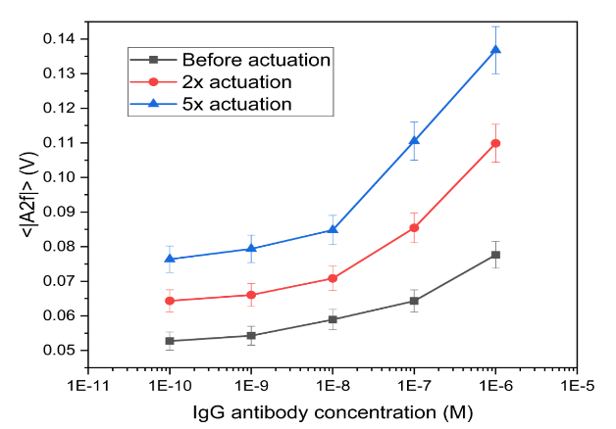
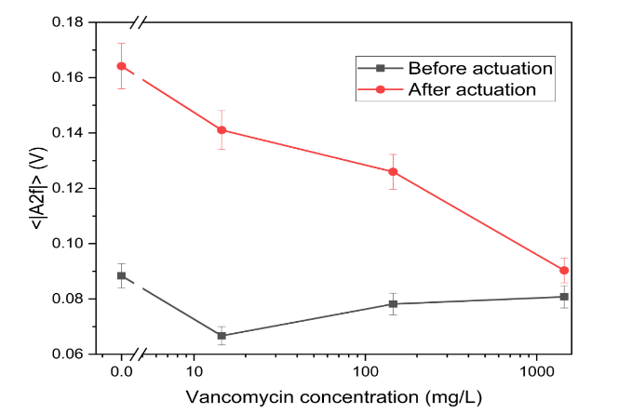
Figure 4: (a) Graph of the |A2f| signal as function of the poly-IgG concentration. The higher the poly-IgG concentration, the higher the |A2f| signal, which will result in a larger range for proof-of-concept measurements. (b) Dose-response curve of free vancomycin. The red line indicates the signal after 8 actuation pulses and the grey line shows the signal before the actuation sequence.

Novelty and Creativity

Already available
Our biosensor system is based on the principle of the rotating magnetic cluster assay studied by Andrea Ranzoni [1]. The miniaturization of the hardware components of the sensor into a table-filling biosensor was already demonstrated by the previous T.E.S.T. team in 2017.

New developments

Chemical developments
Previous iterations of the rotating magnetic cluster assay have used a sandwich principle: an analyte is sandwiched between two antibody functionalized beads to form dimers. This is a two component system suitable for analytes that have the capacity to bind to two antibodies. Analytes that are too small to bind to two antibodies at the same time are thus not measurable using this principle.
This year, we have demonstrated the usage of a chemical principle using three components (functionalized beads, free antibodies and free analyte) that allows for the detection of vancomycin, an analyte far too small to bind to two antibodies simultaneously. This development indicates the flexibility of the detection principle and promises further expansion of the number of biomarkers this system can measure. As long as the analyte (or an analogue) can be attached to the surface of the beads without compromising its ability to bind to an antibody, this three component competition assay principle can be utilized.
Moreover, we have demonstrated the fact that the dynamic range of this measurement principle can be extended into the micro molar range. Previous publications by Ranzoni and the T.E.S.T. 2017 have proven the principle to be capable of measuring in picomolar ranges.
Combining the adaptability and scalable dynamic range of the chemical principle, we can conclude that this technique is a viable option for multiplexing if a sophisticated cartridge design can be developed.

Hardware developments
The bottom plate of the sensor was 3D printed in such a way that all the parts directly fit into the right place, only one Raspberry Pi was needed and the diode was put at a 90 degree angle .These improvements of the biosensor hardware made the sensor smaller and lighter. Safety precautions were also built into the hardware of the sensor, a safety switch was installed making sure the laser is switched off when the sensor is open. A new way of placing the sample in the sensor was developed to improve the user friendliness of the sensor. The first prototype of placing the sample in the sensor is a small holder for a glass cuvette held together by two springs, keeping the sample steady. Later this holder can be replaced by a cartridge.
The software used was written by ourselves and made user friendly and easily adjustable. The new software makes it possible for home care workers to log in to their own account, where they can easily make a measurement or check the previous results. Another feature is the ability to change settings of the quadrupole magnet directly on the sensor itself. Furthermore, the results can be send to the user via email. This is done in such a way that even after restarting the sensor, the data can still be sent if the corresponding patient id is entered into the sensor.
These hardware and software improvements contribute to the user friendliness, making it possible for the biosensor to be used outside the hospital. We are proud of the new way in which our biosensor makes it possible for patients to recover at the comfort of their own home.

Translation potential

Stakeholder desirability
Initially, our hypothesis was that vancomycin was mainly used to treat MRSA. However, vancomycin is not very commonly used for patients with MRSA as it is not common in the Netherlands. Instead, it is used for the treatment of infections due to operations, for example. This treatment is carried out more and more at home, because these patients are generally stable which makes it unnecessary for them to stay in the hospital.
Some hospitals are currently piloting a home care program for vancomycin. Either caretakers take blood at home and transport it to the hospital or patients themselves send blood spots to the hospital, only requiring a finger prick. While the last option saves time for the patients, it is not favored amongst chemists because it takes them more time to process the blood spots.
Home care currently causes logistical problems because the transport of blood to the hospital (or lab) takes a long time. This means that dosage is based on information of the day before instead of recent information. Hospitals are often large institutions where everything has to be documented before it passes a certain checkpoint, which makes moving things like blood very time-consuming.
This is where our biosensor could be a relief as it could nullify these problems with the right communication technologies. Vancomycin levels can still be monitored at home, while hospital workload is decreased by reducing the amount of occupied hospital beds. This way we relieve two pains at the same time: we remove the logistical step, saving time and we reduce the workload of hospital personnel. This makes hospitals more inclined to move patients from the hospital to homecare.
At the same time the biosensor creates value for multiple stakeholders. Patients are able to recover in the comfort of their home and are no longer required to give vials of blood for analysis, a small finger prick suffices. Doctors and other assisting hospital personnel, like nurses, have their workload decreased. The hospital (direction level) has less costs on hospitalized patients, who are stable enough to move to homecare. In the long term the biosensor will also be able to cut back on costs of health insurance companies.
To fulfil these gains our prototype needs some more developing. It is already able to detect vancomycin with a single drop of blood in a few minutes. The user interface and outer design have been made in such a way that they are as user friendly and dummy proof as possible. It has been made as small as physically possible, with regard to our detection principle.
However in order for the measurement to be carried out at home, a cartridge has to be developed. The cartridge is a small reaction chamber which, with the help of microfluidics, is able to replace our current cuvette and processing steps. Secondly, the biosensor will have to be linked to the hospital patient data servers. This allows our biosensor to directly sync the measured results with the patient document, so that further logistics are no longer necessary. The doctor and pharmacists will be able to directly review these results and provide feedback on the treatment of the patient. The clinical chemist will no longer be needed to carry out this measurement.

Technological feasibility
Our sensor is suitable for industrialization: all but two parts are commercially available and to industrialize it, we would merely have to order more. Two parts in the biosensor are not available for purchase: The casing of the sensor and the quadrupole magnet. The casing has been 3D printed so 3D printers can be bought and put to service. The casing makes the industrialization easier, because it indicates which components needs to be placed where. For the quadrupole magnet we would have to create a new industrial process, as the process we currently used was aimed towards specialized manufacture.
As of this moment, we do not plan to make our sensor smaller, nor do we think it would be useful.
The biggest gap between our prototype and the envisioned end product is the lack of a cartridge. Our sensor is, as it is now, not compatible with cartridges. To make our sensor ready for the use of cartridges, we will have to alter the cuvette holder into a cartridge holder. We may also have to make some adjustments to the reaction chamber if we want to measure from only a single drop of blood. The most important thing about the cartridge is that it is completely transparent (like the cartridges used in the Magnotech of Philips), otherwise the cartridge will not be compatible with our measuring principle.
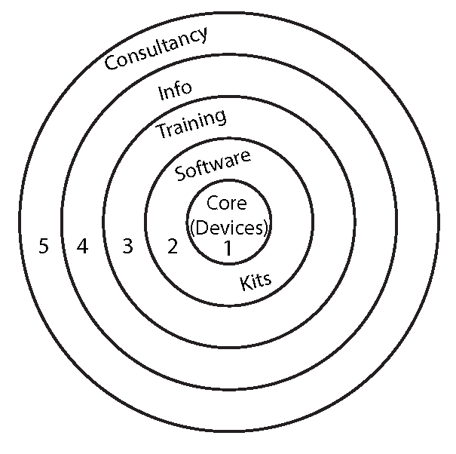
To make a cartridge equivalent for our sensor, the chamber in the cartridge will consists of respectively a water soluble film (which will dissolve once in contact with blood), a chamber with our functionalized magnetic beads, a water soluble film and a chamber with the antibodies. This order is essential for the assay to work.
Figure 5: Schematic represantation of the business proposition.

Business viability
Our proposition consists of multiple layers. Layers (1) and (2) (Figure 5) will be sold at their cost price plus a small margin (see Appendix for comprehensive cost and sales analysis). The reason for this is that it is essential for this product to first establish plenty of coverage in The Netherlands, as this is part of our strategy. The target is to achieve an implementation of 15% of the maximum possible market (Table 1) within 3 years after entering the market, otherwise we believe the market is not profitable. This would mean we sell 13 biosensors in the Netherlands which would generate a revenue of €63.000 and a gross margin of €20.000. We want to provide an offer per hospital where proposition (1) and (2) are always sold and (3), (4) and (5) are optional. Software for detection of a specific biomarker will be sold in the form of licenses on a yearly basis, this way the client can reconsider the offer every year. This way, hospitals can choose which biomarkers they want once more markers are possible to be measured with our device. For the first years only 1 license per device will be necessary and the price for this is set at €200 (Table 5).
After a stable market share has been achieved we will expand into developing new cartridges which (in combination with the right software) are able to detect new biomarkers. Revenue will greatly increase once multiple cartridges are on the market. Examples of these which are useful for vancomycin treatment are MDRD, creatinine (both indicators of kidney function) and CRP (infection parameter).
The training (3) (Table 3) we provide at the hospital for the homecare workers will go into depth about the use of biosensors at the home of a patient. Because biosensors aren’t used much in homecare yet, we think it is essential to provide information about how to create a safe and assuring environment for the patient and the homecare worker while using the biosensor.
In our literature research, we found that it is quite difficult to find data about vancomycin patient numbers and properties. We could not find how patients are being treated nor how treatment differs from patient to patient. We want to exploit this by selling information (4) to hospitals and potential other companies. Information about other types of patients can also be sold once the biosensor is able to detect multiple biomarkers. We know anonymous patient data is a billion dollar industry [2], however pricing and size of databases is usually kept secret so it is not possible at this point to make a realistic estimation of the costs and revenues. Consultancy (5) will be done in the long term after more knowledge has been gathered about this market. We will consult on how patients can be monitored best; in what ways you can do this and which sensor suits this type of monitoring and the hospital.
Overall: at first the revenue come from the biosensor, software & cartridges. Trainings will also be an important part of the company in the first years to ensure a positive implementation in hospitals. In the long term most revenue will be generated through cartridges, providing a more stable income. Next to that, we will shift to a more service oriented offer, in order for the company to start making profit.

Investment proposition
The investment proposition (Figure 6) gives an overview of the monetary returns gained after an investment in T.E.S.T.. At a macro level (meaning the entire health care sector) the costs per patient can be reduced up to €4.000 by trading in a DBC of 6-28 hospitalization days for a DBC of 5 hospitalization days [3]. Since health care is so complex, it’s very hard to pinpoint who directly benefits from this. However, health insurance companies provide the budget for hospitals and pay for patient care (in hospitals), so this reduction is indirectly and in the long term a benefit for the health insurance companies. A shift in DBC’s used does not benefit hospital profit as much. The real reduction in costs for the hospital is made by moving a patient to homecare earlier. This can save around €180 per day when a patient is moved to homecare before the final DBC date. If our biosensor would be able to cut an average hospitalization time of a patient by 10 days, then a return on investment is made once 9 patients are moved from the hospital to homecare. This calculation is worst case, as other (financial) benefits have not been taken into account.
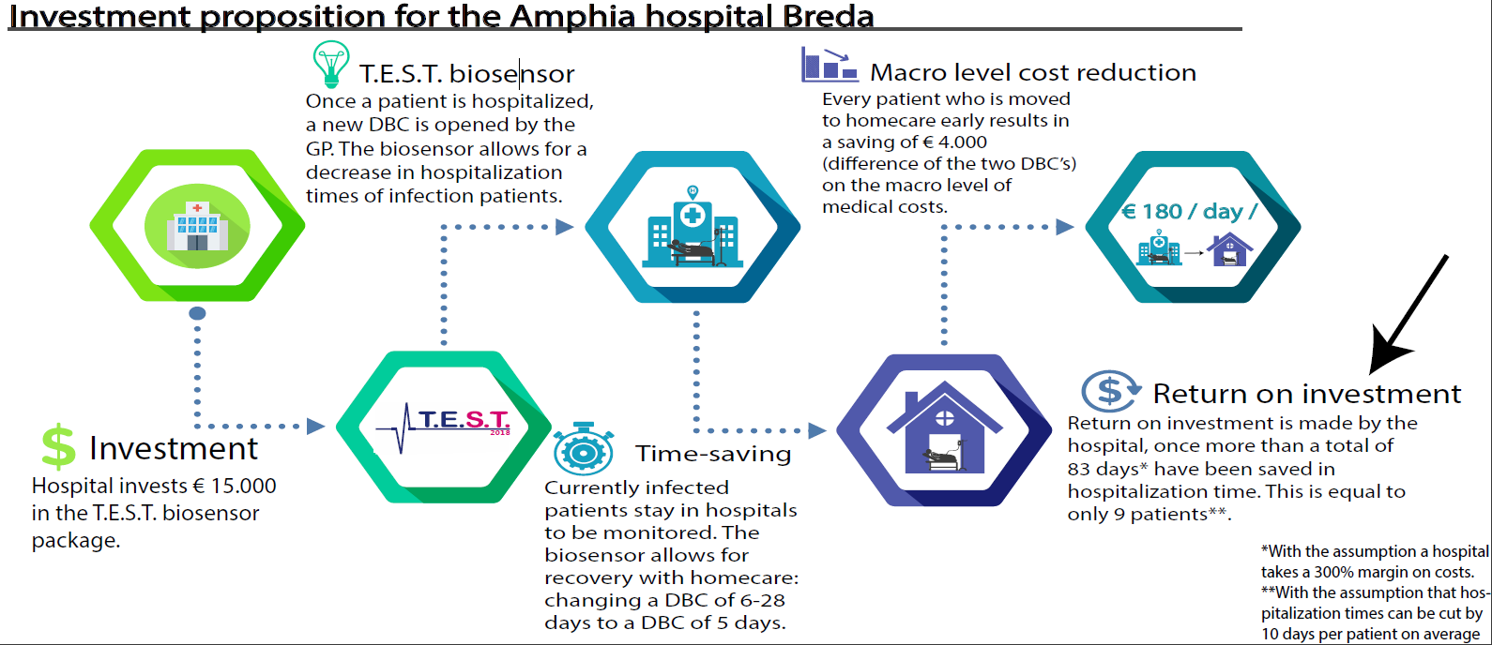
Figure 6: Schematic representation of the investment proposition for the Amphia hospital Breda.

Team and support

Contributions of the team members
This year, the TU/e Sensing Team consisted of 11 bachelor students from 7 different studies. In the table below, the organization of our team is shown
Subteam | Responsible | Subteam members
Chemistry | Jorg Mallens | Saray Bakker, Lotte Van Dasler, Leander van Eekelen, Janneke Lukkezen, Céline Pereboom, Dennis van de Sande, Ivar de Vries
Hard/software | Ivar de Vries | Tom Franken, Ralf Schmidt
Translation potential | Robert van Dijk | Tom Franken, Jorg Mallens
Sponsoring | Leander van Eekelen | Lotte van Dasler, Tom Franken, Janneke Lukkezen, Céline Pereboom, Jorg Mallens
Public relations | Céline Pereboom | Lotte van Dasler, Dennis van de Sande

People who have given support
Advisors: We are deeply grateful for the support of our advisors, Dr. Leo van IJzendoorn, Max Scheepers MSc., and Claudia Schot. Leo helped us keep an eye on the bigger picture and set goals, while Max helped us with experimental design and day-to-day work in the lab. Claudia aided in logistics and was our liaison for the ordering of chemicals. Together, they all provided much needed feedback on our ideas and thoughts.
Future Diagnostics: Mike Martens, Ernst Lindhout and colleagues from Future Diagnostics provided feedback from the perspective of the bioassay industry on our initial design, which eventually led to its adoption as the final design.
Amphia hospital of Breda: Marloes Langelaan, Nils van ‘t Veer and colleagues helped immensely to define the clinical context of our problem and provided subsequent feedback on our proposed design.
Paul Kemper: With years of experience in both programming (apps, hackathons, software development) and marketing, Paul helped us with both our public relationships and the programming of the biosensor.
Sponsors
Relitech: Relitech provides engineering solutions for the medical industry, acting like an extension of the R&D department of a company. They aided us via the donation of monetary funds.
Oceanz: Oceanz is the leading provider of 3D printing solutions for the medical industry. Oceanz aided us by printing the case of our biosensor to spec for a reduced fee.
Xendo: Xendo is a leading consultancy and project management organisation in the field of medical devices. Together with them, we examined the European Legislation for In-vitro diagnostics.
TU Eindhoven: Starting this year, T.E.S.T. is an official student team of the TU Eindhoven. In cooperation with the TU, we attend events such as the Dutch Technology and Dutch Design weeks. We receive yearly monetary funds from the TU.

Final remarks
We have tried multiple approaches in order for our assay to work. We have used different kinds of surfactants like BSA and Pluronic to reduce aspecific clustering of the magnetic beads after actuation.
We also came up with a two new alternatives to replace anti-vancomycin antibodies in the competition assay. The first one is a peptide of two D-Ala-D-Ala sequences linked together with a linker protein. D-Ala-D-Ala is a peptide sequence which can be found in the cell wall of gram positive bacteria. Vancomycin function as an antibiotic is based on binding to this specific site, inhibiting cell wall synthesis of the bacteria [4].
Another alternative for antibodies are magnetic beads coated with D-Ala-D-Ala. This way ,the beads coated with vancomycin and the beads with D-Ala-D-Ala can form a dimer together. When vancomycin is introduced this can block the dimer formation by binding to the D-Ala-D-Ala beads. Antibodies are expensive and can differ per batch so if you can replace that with one of the two options above that would be very convenient
These alternatives would both reduce production costs of the cartridge by eliminating the need for the expensive antibodies as well as eliminate the differences between batches (which occur with antibodies). However, the synthesis of the D-Ala-D-Ala protein did not work in time, for the future this could be a cheaper option for antibodies.

References

General
[1] A. Ranzoni, X. J. A. Janssen, M. Ovsyanko, L. J. Van IJzendoorn, and M. W. J. Prins, “Magnetically controlled rotation and torque of uniaxial microactuators for lab-on-a-chip applications,” Lab Chip, vol. 10, no. 2, pp. 179–188, 2010.
[2] A. Tanner, Our Bodies, Our Data. How companies make billions selling our records, Beacon Press, 2017.
[3] N. Zorgautoriteit, "DBC-Zorgproducten," 2018. [Online]. Available: http://opendisdata.nl/msz/zorgproduct. [Accessed May 2018].
[4] National Center for Biotechnology Information. PubChem Compound Database; CID=14969, https://pubchem.ncbi.nlm.nih.gov/compound/14969 (accessed Aug. 29, 2018).

Translation potential
Validation has been done by talking to/interviewing professionals and customers. An overview of all contacted people, contact info is available on request:
Erasmus MC: Birgit Koch (hospital pharmacist)
AMC: Yuma Bijleveld (hospital pharmacist) & Annabel Werumeus (hospital pharmacist)
Amphia: Nils van ‘t Veer (hospital pharmacist), Alina van der Giessen (clinical physicist), Marloes Langelaan (clinical chemist) and Inge Veltman (advisor innovation)
Maastricht UMC: Thomas Havenith (hospital pharmacist)

Maxima MC Eindhoven: Luc Derijks (hospital pharmacist)

Appendix

Revenue streams calculations
Table 1: Market size for the T.E.S.T. biosensor
What? | Numbers | Comments
Number of vancomycin patients Amphia  Number of vancomycin determinations Amphia | 7 – 10 per week  364 – 520 per year | Assuming every patient being treated requires 1 determination per week on average  (this is a low estimate as daily determinations also occur in earlier stages of treatment).
Adherent inhabitants Amphia | 400.000 | Extrapolate for The Netherlands
Number of vancomycin determinations in The Netherlands | 15.500– 22.100 per year | 42.5 x 364 (17.000.000/400.000 = 42.5)  42.5 x 520
Total number of hospitals in The Netherlands | 80 | It is assumed that every 200.000 inhabitants will need a T.E.S.T. sensor. This would be 1 sensor for every 4-5 vancomycin patients
Amount of T.E.S.T. sensors implemented in the Netherlands | 85 | 17.000.000/200.00
Total revenue of nationwide  implementation | €425.000  15% market: €63.750 | 85 x 5000  Expected technical lifespan is 5 years. Meaning these numbers reoccur every 5 years.
Gross margin on nationwide implementation of the sensor | €127.500  15% market: €19.125 | 425.000-85 x 3500 (cost price)
Table 2: Market size for only vancomycin cartridges. These values will be multiplied for every new biomarker which the biosensor can detect.
What? | Numbers | Comments
Current vancomycin cartridge cost | 1,90 € | Based on Amphia prices
T.E.S.T. vancomycin cartridge selling price | 4,90€
Production costs per vancomycin T.E.S.T. cartridge | €2,96 | Based on the chemicals costs in the cartridge
Gross margin per vancomycin cartridge | €1,94
Revenue on T.E.S.T. cartridge in the Netherlands (yearly, at full implementation) | €76.000-110.000  15% market: €11.400 | 4,90*Number of vancomycin determination
Gross margin in T.E.S.T. cartridges in the Netherlands (yearly, at full implementation) | €30.000-43.000  15% market: €4500
Table 3: Market size for training, information and consultancy sales. Information and consultancy are types of revenue for which it is unclear as of now how much they are worth.
What? | Numbers | Comments
Training of homecare staff | Min. € 7.500  Max. € 236.250 | Assumption: 1 training per hospital and minimum is 10.
Information sales | NaN | NaN
Consultancy | NaN | NaN

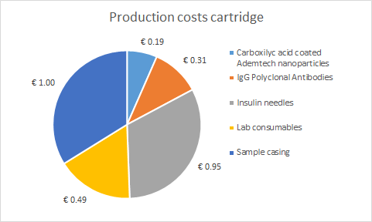
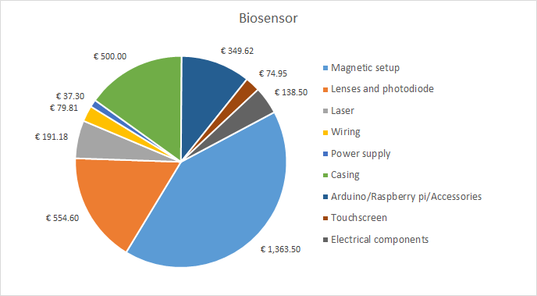
Figure 7: (a) Current production costs of the T.E.S.T. biosensor. (b) Current production costs of the cartridge.
Table 4: Vancomycin relevant DBC's:
DBC | DBC cost (average in The Netherlands)*
(1) Hospitalization with a maximum of 5 nursing days in case of an infection | € 2.650
(2) Hospitalization with 6 up to a maximum of 28 nursing days in case of an infection | € 6.685
Table 5: Investment proposition for Amphia
Proposition layer | Investment size
(1) Devices (QC/guarantee) | € 10.000 (2 x 5000€)
(2) Software  Cartridges  (both required) | € 400 (2 x 200€)  € 1.784 – 2.550  (364 to 520 measurements in a year with a cartridge cost of € 4,90)
(3) Training  Homecare / user training | € 750 (single training for homecare staff)
(4) Information sales | -
(5) Consultancy | -
Total: | € 13.600
Table 6: Fixed startup costs estimation.
What? | How much? | Why?
Patent on the assay principle | € 25.000 to € 50.000 filing  € 20.000 / year | There already exists a patent from the TU/e on the assay used last year. Our assay differs slightly however.
CE approval | Max. € 64.000 | Required to enter market  Most likely less, as we’ve already kept the IVDR in mind during prototype development.
Employees | € 1.500/ month / employee
Office rent | € 2.000 / month
R&D equipment, parts, reagentia, etc.  (depreciation of inventory) | € 500.000 | Lots of R&D has to be done before we can enter the market. Development of the cartridge will take some time and costs.
Production of first 10 biosensors and 400 cartridges (3 month supply) | € 35.000 + € 996 | We should have some product we can immediately sell, once we enter the market.

All references are listed in the reference section.
This is a package of healthcare linked to a set price.

